**Phase 09: Vipers**

**Modified Requirements for Car Rental Management System**

A local car rental agency, Vipers, provides rental cars to the public. They rent cars upon booking from the customers. They offer wide range of cars models to choose from. Each car is classified into a SUV, or sedan or Coupe. We have included an “attribute define hierarchy” for the relation car based on the attribute “model”. We keep track of each person’s DOB, name, address and mobile number in the database. Each person is uniquely identified with an ID. A person in our database can further be sub categorized into either a Customer or an employee. If it is a customer then his driver’s license, start date with the agency and membership id are maintained in the database as well. If the person happens to be an employee, his mailed and employee id are to be kept in track. In addition to the on spot booking at their local office, they also have a website from which the customers can make online booking. Time for which the car needs to be rented has to be determined by the customer before renting the car. The office usually opens at 7.00 A.M. in the morning and closes at 8.00 P.M. Customers can pick up the car only during the working hours but has the liberty to drop off the car at the office even during the closed hours. Customers will not be charged with any fee if they cancel their booking within two hours of their registration. Any later cancellations are charged with a minimal amount of fees. Late car returns are charged in relation with the number of hours delayed.

Customers must provide a valid driver’s license before picking up the car. They have to pay extra to add co-driver. Customers are charged depending upon their age. Repeated customers are provided with a membership and will get an additional discount. First time customers will get a fifty percent discount on their first booking. They also offer special prices for a day rental on some selected cars with a restriction on distance. The customers are provided with several insurance policy to choose from that cover for damages, in case of any accidents. They are given liberty to use their own insurance.

The company keeps the cars serviced for every 5000 miles. They keep the vehicles in good condition and insurances up to date. They always fill the fuel before handing over the vehicle to the customers.

**Phase 09: Vipers**

EER Diagram

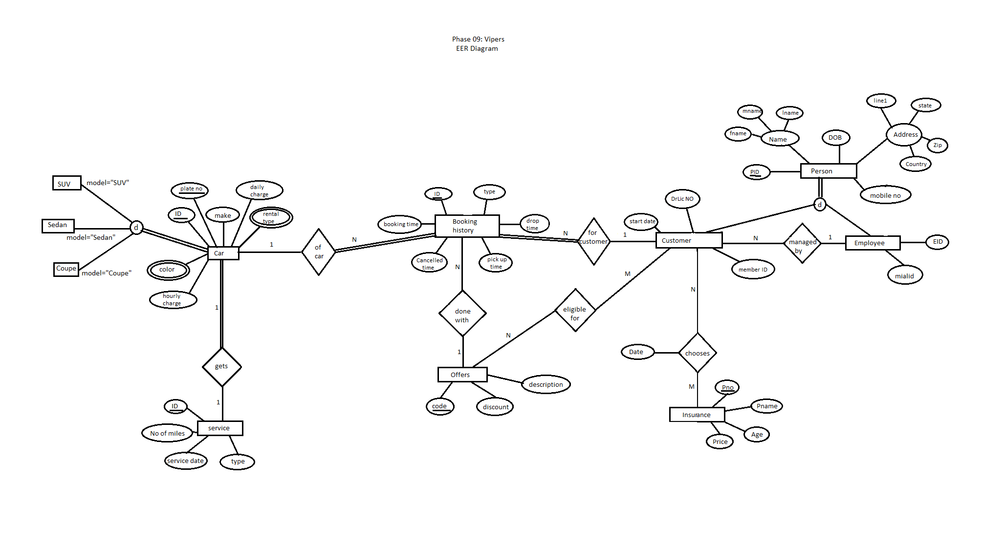

**Phase 09: Vipers**

Most recent ERD

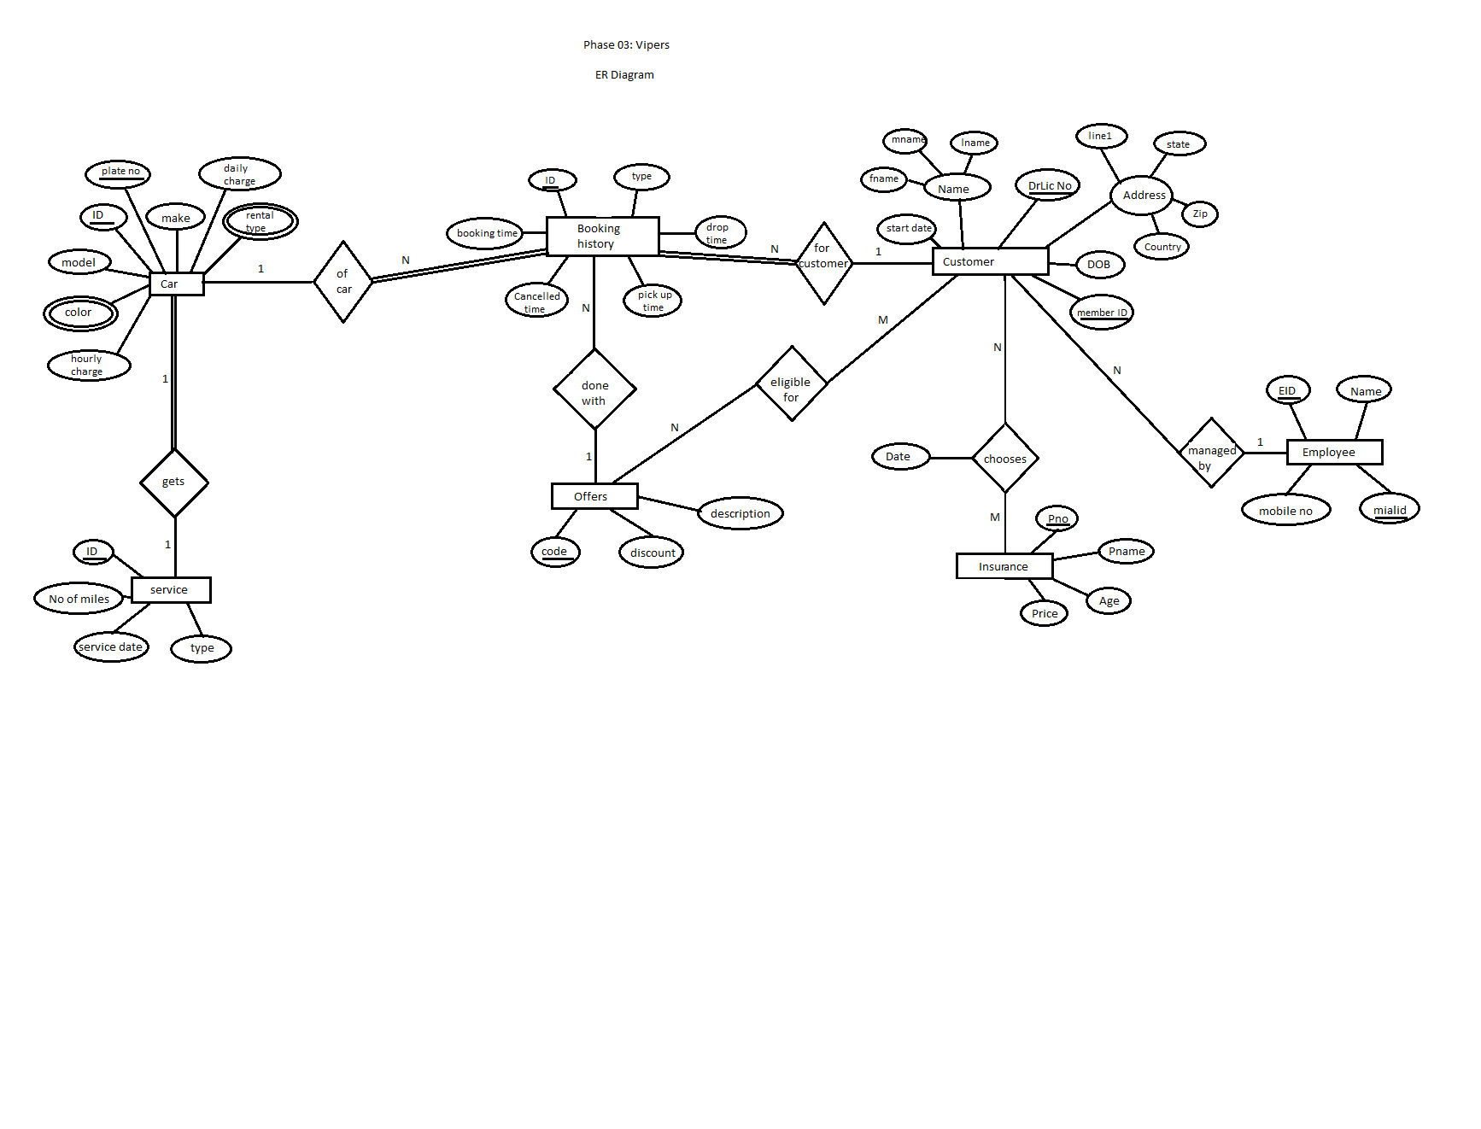

**Phase 09: Vipers**

Relational Schema as per EER

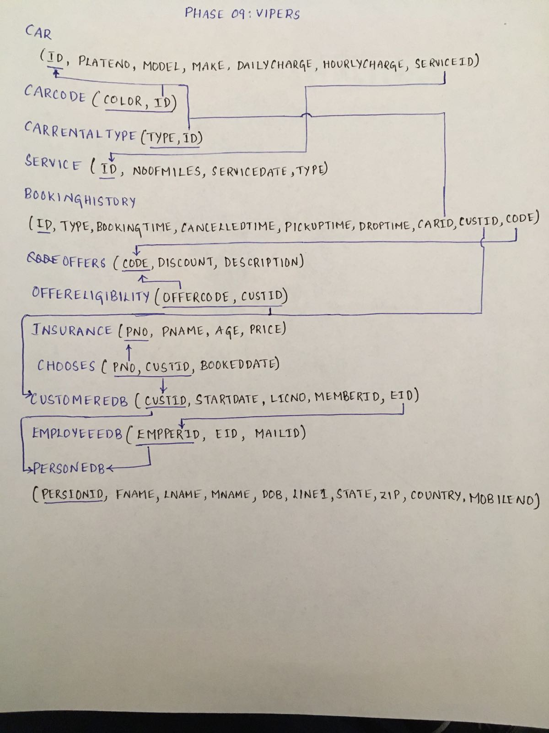

**Phase 09: Vipers**

***Assertions:***

CREATE ASSERTION PERSONTOTALSPECIALIZATION CHECK (NOT EXISTS

(SELECT * FROM PERSONEDB P WHERE P.PERSONID NOT IN

(SELECT C.CUSTID FROM CUSTOMEREDB C

UNION

SELECT E.EMPPERID FROM EMPLOYEEEDB E)))

CREATE ASSERTION ONLYCUSTOMERS CHECK (NOT EXISTS

(SELECT * FROM OFFERELIGIBILITY O WHERE O.CUSTID IN

(SELECT E.EMPPERID FROM EMPLOYEEEDB E)))

**MOST RECENT RELATIONAL SCHEMA**

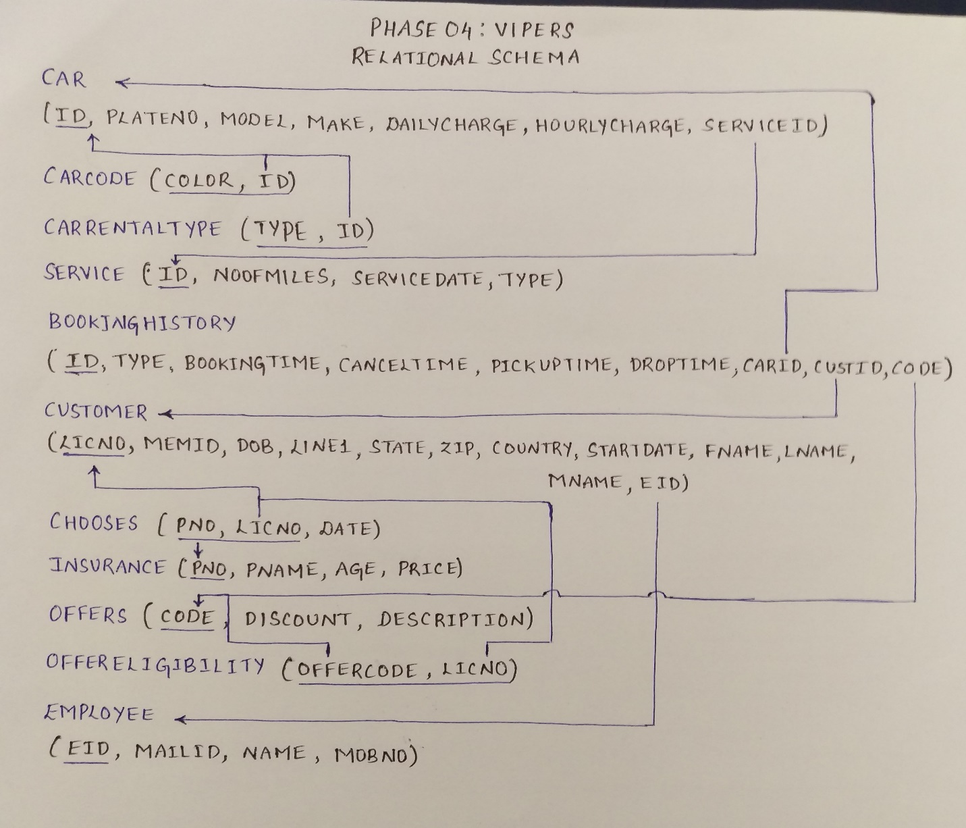

**Phase 09: Vipers**

**UML DIAGRAM**

